FTR Schematic Checklist

First-Time-Right Schematic Checklist
Design: AtmosTag
Revision: V1.2
MCU: STM32L031G6U6
EPD: 2.13" e-paper
Primary analog: GUVA-S12SD + MCP6002
USB: CP2102N
EDA: EasyEDA

1. Requirements Before Schematic Freeze
- Every electrical requirement has a measurable acceptance criterion.
- Input voltage range has been defined, including minimum, nominal, and maximum.
- Required operating temperature range has been defined.
- Maximum active current has been estimated.
- Maximum sleep current has been estimated.
- Battery/source characteristics have been defined.
- Required EPD operating voltages have been taken from the actual EPD specification.
- Required EPD refresh behavior has been defined.
- Required UV measurement range and accuracy have been defined.
- Required temperature/humidity measurement accuracy has been defined.
- USB operating requirements have been defined.
- Required MCU clock accuracy has been defined.
- Every requirement has been traced to at least one schematic design decision.

2. Datasheet-to-Schematic Verification
- The latest datasheet for every critical IC has been reviewed.
- Recommended application circuit has been compared against the schematic.
- Absolute maximum ratings have been checked.
- Recommended operating conditions have been checked.
- Minimum/maximum external component values have been checked.
- Required external components have been identified rather than assuming the reference circuit is complete.
- Device-specific startup requirements have been checked.
- Shutdown/low-power requirements have been checked.
- Internal pull-ups/pull-downs have been identified before adding external ones.
- Reserved and NC pins have been handled according to the datasheet.
- Package-specific pinout has been checked rather than relying on a generic symbol.
- Datasheet assumptions about external circuitry have been explicitly verified.

Critical devices for independent verification
- STM32L031G6U6
- SHT41-P-NF
- MCP6002-I/MS
- GUVA-S12SD
- CP2102N-A02-GQFN20
- SI1304BDL
- AO3401A
- MBR0530
- EPD panel/interface specification
- EPD boost/reference circuit

3. MCU Pin Assignment
- Every MCU pin assignment has been checked against the STM32 alternate-function table
- No peripheral function conflicts with another required peripheral.
- Analog pins are actually ADC-capable where required.
- I²C pins support the intended I²C peripheral/function.
- UART pins support the intended UART peripheral/function.
- SWD pins remain available.
- Crystal pins support the intended 32.768 kHz oscillator.
- Boot configuration does not conflict with normal GPIO use.
- Every GPIO's power-up/reset state has been checked.
- Every GPIO connected to an external circuit has been checked for back-powering risk.
- Every GPIO connected to an external circuit has been checked for maximum source/sink current.
- No GPIO is relied upon to remain at a specific state before firmware initialization unless hardware guarantees it.
- Pin assignment has been checked against the final firmware pin definitions.

4. Power Tree
- A complete power-tree diagram has been derived from the schematic.
- Every power rail has a defined source, nominal voltage, tolerance, and maximum current.
- Worst-case load has been calculated for every rail.
- Startup load has been considered separately from steady-state load.
- Peak/transient load has been considered separately from average load.
- Power sequencing has been checked for every IC that has sequencing requirements.
- Power-down sequencing has also been checked where relevant.
- No rail can unintentionally be powered through an I/O pin.
- No powered-down IC can back-power another rail.
- USB VBUS and board power paths have been checked for backfeeding.
- Analog and digital power domains are isolated
- All rail tolerances have been propagated to downstream devices.

5. Power Budget & Low-Power Design
- Active current budget has been calculated from individual loads.
- Sleep current budget has been calculated from individual loads.
- Worst-case resistor leakage/current has been included.
- Pull-up resistor current has been included.
- LED current has been included.
- SHT41 consumption has been included.
- MCP6002 quiescent current has been included.
- CP2102N standby/suspend consumption has been included.
- EPD boost quiescent/leakage current has been included.
- EPD boost is guaranteed to be disabled when not required.
- UV circuitry can be disabled when not measuring.
- Analog circuitry does not remain unintentionally powered during sleep.
- Maximum sleep current remains below the system requirement with component tolerances.
- Worst-case battery/source voltage has been used in the power analysis.
- Worst-case temperature effects on current consumption have been considered where important.

6. Power Protection & Fault Analysis
- Reverse-polarity protection has been analyzed for the actual expected fault.
- Overvoltage behavior has been analyzed.
- Short-circuit behavior has been analyzed.
- USB power insertion/removal has been analyzed.
- Simultaneous USB and external power has been analyzed.
- Backfeed paths have been traced manually.
- Every externally accessible signal has been checked against MCU/IC absolute maximum ratings.
- ESD protection requirements have been determined from the actual external interfaces.
- Protection components have been selected based on worst-case fault voltage/current
- Protection components do not interfere with normal signal operation.
- Failure of a protection component does not create an unsafe power path.

7. Decoupling
- Decoupling requirements have been obtained from each IC datasheet.
- Required capacitance has been checked against actual selected values.
- Capacitor DC-bias derating has been considered.
- Capacitor tolerance has been considered.
- Capacitor voltage rating has adequate margin.
- Required bulk capacitance has been calculated from load transients where necessary.
- Regulator stability requirements are satisfied with the selected capacitor type/value.
- No regulator depends on a capacitor whose effective capacitance falls outside its stability range.
- High-current switching sections have been checked for adequate local energy storage.
- Analog/reference rails have sufficient filtering for the required measurement accuracy.

8. STM32L0 Reset, Boot & Startup
- NRST circuit has been checked against the STM32 reset requirements.
- NRST pull-up/pull-down value is appropriate.
- Reset capacitor, if used, has been checked against required reset timing.
- BOOT0 default state has been verified.
- Boot configuration remains valid during power ramp-up.
- SWD remains usable under all intended power conditions.
- No external peripheral can force an MCU pin into an invalid state during reset.
- EPD_EN, UV_EN, and other power-control signals have defined hardware states before firmware starts.
- EPD cannot accidentally start during MCU reset.
- UV circuitry cannot accidentally activate during MCU reset.
- Startup behavior has been considered before GPIO initialization.

9. 32.768 kHz Oscillator
- Crystal load capacitance has been calculated
- MCU pin capacitance and PCB parasitics have been included in the calculation.
- Selected capacitor values provide the required effective load capacitance.
- Crystal ESR is compatible with the STM32 oscillator.
- Crystal drive level is acceptable.
- Startup time is acceptable for the intended low-power operation.
- Oscillator accuracy meets the system requirement.
- Temperature tolerance of the crystal has been considered
- Crystal operation has been checked against the STM32 oscillator configuration.

10. SHT41 I²C Interface
- I²C pull-up values have been calculated from bus capacitance and required speed.
- Minimum and maximum pull-up current are acceptable.
- MCU and SHT41 logic thresholds are compatible across the full voltage range.
- SDA/SCL behavior during reset has been checked.
- No device can hold the bus in an unintended state during startup.
- Bus recovery requirements have been considered.
- Sensor supply tolerance is within specification.
- Sensor measurement timing is compatible with the firmware timing requirement.
- Sensor self-heating implications have been considered.
- SHT41 low-power operating mode has been included in the power budget.

11. UV Sensor / TIA

Photodiode
- GUVA-S12SD spectral response is appropriate for the intended measurement.
- Photodiode polarity has been independently verified.
- Photodiode operating/bias configuration is intentional.
- Photodiode capacitance has been obtained from the datasheet
- Maximum and minimum expected photocurrent has been established.
TIA
- TIA transimpedance gain has been calculated from the required input range.
- Maximum photodiode current does not saturate the amplifier.
- Minimum photodiode current produces sufficient ADC resolution.
MCP6002 input common-mode range is satisfied.
- MCP6002 output swing is sufficient at both minimum and maximum signal.
- Feedback resistor tolerance has been included in gain accuracy.
- Feedback capacitor has been selected from a stability/bandwidth analysis.
- Photodiode capacitance and amplifier input capacitance have been included in the stability analysis.
- TIA phase margin/stability has been considered.
- TIA bandwidth is sufficient for the intended measurement.
- TIA bandwidth is not unnecessarily large for a low-noise sensor measurement.
- Op-amp input bias current error has been checked against the minimum signal.
- Op-amp input offset error has been checked against the required measurement accuracy.
- Resistor thermal noise has been considered where it materially affects the measurement.

Second Amplifier / ADC
- Second-stage gain has been calculated.
- Any intended offset/bias voltage has been calculated.
- Maximum UV_SIG remains below the STM32 ADC maximum input voltage.
- Minimum UV_SIG remains inside the intended ADC operating range.
- ADC resolution is sufficient for the required UV measurement resolution.
- ADC source impedance is compatible with STM32 ADC acquisition requirements.
- RC filtering has been checked against ADC sampling/acquisition time.
- Total analog gain has been checked from photodiode current → TIA → amplifier → ADC.
- Worst-case component tolerances have been propagated through the complete analog chain.
- Saturation recovery behavior has been considered.

12. Analog Power & Ground Architecture
- AVCC filtering has been justified by the analog accuracy requirement.
- MCP_AVCC voltage remains valid under worst-case analog load.
- Analog supply ripple requirement has been established.
- AGND/GND connection strategy is deliberate.
- High-current EPD switching currents have a defined return path that does not compromise the analog reference.
- Digital switching noise coupling into the UV measurement has been considered at schematic level.
- ADC reference/supply noise has been considered.
- Analog measurement accuracy includes supply and ground error sources.

13. EPD Interface
- The actual EPD panel datasheet/interface specification has been used.
- Every FPC pin has been mapped from panel specification → connector → schematic net.
- Connector pin numbering has been checked independently from the symbol.
- Connector orientation has been checked independently from the footprint.
- Logic supply voltage is compatible with the EPD.
- EPD logic signal voltage levels are compatible with STM32.
- EPD_BUSY direction is correct.
- EPD_RST polarity is correct.
- EPD_DC polarity/function is correct.
- EPD_CS polarity/function is correct.
- EPD_BS configuration is correct.
- EPD_RESE/GDR functions have been verified against the actual driver architecture.
- No panel pin has been inferred from another panel's pinout.
- No unused panel pin has been assumed to be harmless without checking the panel specification.

14. EPD High-Voltage Boost
- The exact EPD required VGH/PREVGH voltage has been verified.
- The exact EPD required VGL/PREVGL voltage has been verified.
- Positive/negative rail polarity has been independently verified.
- Required voltage tolerance has been established.
- Maximum EPD load on each HV rail has been established.
- Boost topology has been verified against the intended EPD driver/reference circuit.
- Inductor value has been verified from the converter design requirements.
- Inductor saturation current exceeds worst-case peak current with margin.
- Inductor RMS current rating is adequate.
- Inductor DCR loss has been considered.
- Diode reverse-voltage rating exceeds the worst-case node voltage.
- Diode peak and average current ratings are adequate.
- MOSFET VDS rating has adequate margin over every possible switching-node voltage.
- MOSFET VGS rating is respected during startup and shutdown.
- MOSFET RDS(on) is acceptable at the actual gate voltage.
- Switching losses have been considered.
- Conduction losses have been considered.
- Boost efficiency has been estimated.
- Worst-case thermal dissipation has been estimated.
- HV capacitor voltage ratings include sufficient margin.
- Effective capacitance after DC-bias derating is sufficient.
- HV capacitor ripple current is acceptable.
- PREVGH and PREVGL loads have been analyzed separately.
- HV startup time is acceptable.
- HV discharge behavior after disable has been considered.
- EPD_EN cannot produce an undefined boost state.
- Boost startup does not violate any EPD sequencing requirement.
- Boost shutdown does not leave an invalid EPD state.
- No HV node can reach an MCU GPIO under a single-component fault that is reasonably foreseeable.
- The complete boost circuit has been compared against the actual reference design, not merely judged from topology appearance.

15. USB / CP2102N
- CP2102N power architecture has been checked against the datasheet/reference design.
- VBUS/VREGIN/VDD relationships are correct.
- USB D+ and D− connections are correct.
- USB logic voltage is compatible with STM32.
- CP2102N TX/RX directions are correct.
- CP2102N reset behavior has been checked.
- Required CP2102N decoupling is present and correctly specified.
- USB ESD protection voltage rating is appropriate.
- USB ESD protection capacitance is acceptable.
- USB VBUS loading is within specification.
- USB suspend/low-power behavior has been considered.
- USB cannot unintentionally power the rest of the system through signal pins.
- Simultaneous USB and other power-source conditions have been analyzed.
- USB interface behavior during MCU reset has been considered.

16. MOSFET-Controlled Power Sections
For Q1/Q2/Q3/Q4:
- MOSFET topology has been identified: high-side, low-side, load switch, reverse protection, etc.
- Body-diode direction has been explicitly checked.
- Gate default state has been explicitly defined.
- Gate voltage during MCU reset has been checked.
- Gate-source voltage remains within limits.
- MOSFET is fully enhanced at the actual available gate voltage.
- RDS(on) has been checked at that gate voltage.
- Maximum current has been calculated.
- Power dissipation has been calculated.
- Worst-case junction temperature has been estimated.
- Turn-on/turn-off behavior is appropriate for the connected load.
- No MOSFET can unintentionally latch a power rail on.
- No MOSFET body diode creates an unwanted backfeed path.

17. Passive Component Worst-Case Analysis
- Every resistor with a functional role has a tolerance requirement.
- Every critical resistor has been checked for power dissipation.
- Every critical capacitor has been checked for voltage derating.
- Every timing/filter capacitor has been checked for tolerance.
- Every inductor has been checked for saturation and RMS current.
- Every diode has been checked for worst-case voltage and current.
- Every MOSFET has been checked for voltage, current, gate voltage, and power.
- Component tolerances cannot push an ADC input outside its valid range.
- Component tolerances cannot cause analog-stage saturation.
- Component tolerances cannot cause an EPD rail to exceed its permitted voltage.

18. Startup, Shutdown & State-Transition Analysis
Review the schematic at these exact states:

Power applied
- All rails rise to valid levels.
- MCU starts in a defined state.
- EPD boost remains disabled until intentionally enabled.
- UV circuit remains disabled until intentionally enabled.
- No peripheral back-powers another rail.

MCU reset
- Every externally controlled signal has a safe state.
- EPD does not receive an invalid command/control sequence.
- EPD HV generation remains safe.
- UV circuitry remains safe.
- Buttons do not create unintended current paths.

MCU sleep
- Intended power domains actually become inactive.
- No GPIO back-powers a peripheral.
- Pull-up/pull-down currents are acceptable.
- USB circuitry behaves as intended.
- EPD HV rails behave as intended.

Wake-up
- Required peripherals can be powered/enabled correctly.
- I²C bus starts in a valid state.
- Analog circuitry reaches a settled state before ADC measurement.
- EPD supply reaches valid conditions before EPD commands are issued.

Power removal
- No rail is held up unintentionally.
- No IC is partially powered through an I/O.
- EPD HV rails discharge appropriately.
- No reverse-current path exists.

19. ERC & EasyEDA Integrity
- ERC has been run after the schematic is functionally complete.
- Every ERC error has been investigated.
- Every ERC warning has been investigated.
- ERC exceptions are intentional rather than ignored for convenience.
- Power-input pins are correctly recognized by EasyEDA.
- Intentional power connections are explicitly recognized by the ERC system.
- No hidden global-net connection creates an unintended circuit.
- No duplicate net label creates an unintended connection.
- No symbol pin type incorrectly suppresses a real electrical error.
- ERC-clean status has not been treated as proof of functional correctness.

20. Independent Review
Before schematic freeze:
- A second pass has been performed without looking at the previous checklist results.
- Critical IC pinouts have been independently rechecked.
- EPD FPC mapping has been independently rechecked.
- EPD HV polarity and voltage requirements have been independently rechecked.
- UV TIA calculations have been independently rechecked.
- Power-tree calculations have been independently rechecked.
- USB/CP2102N power and signal architecture has been independently rechecked.
- Worst-case component ratings have been independently rechecked.
- Startup/shutdown behavior has been independently reviewed.
- Firmware-dependent assumptions have been explicitly identified.
- Any remaining uncertainty has been resolved from a datasheet, reference design, calculation, or experiment.

21. Schematic Freeze Gate
Do not freeze the schematic until:
- All critical calculations have numerical results.
- All critical IC circuits have been compared against their reference designs.
- All critical interfaces have been independently pin-checked.
- All power rails have a completed worst-case budget.
- All analog gains/ranges have a completed worst-case calculation.
- EPD HV generation has a completed worst-case voltage/current/thermal analysis.
- Startup and shutdown behavior has been reviewed.
- Fault/backfeed paths have been reviewed.
- ERC is clean or every exception is documented.
- BOM part numbers have been frozen for all electrically critical components.
- No component value is selected merely because it is a "typical" value.
- No circuit block is accepted merely because it resembles a reference schematic.
- Every unresolved design assumption has been eliminated or explicitly accepted as a known risk.

First-Time-Right Critical Gates
For this board, these are the highest-priority schematic checks:
- EPD FPC pin mapping independently verified
- EPD VGH/VGL requirements independently verified
- EPD boost topology mathematically verified
- EPD MOSFET/diode/inductor worst-case ratings verified
- EPD startup/shutdown sequence verified
- GUVA-S12SD polarity and operating configuration verified
- 1 MΩ TIA gain and stability verified
- Complete UV analog gain/range calculated
- UV_SIG worst-case ADC range verified
- MCP6002 input/output limitations verified
- VCC → AVCC → MCP_AVCC power architecture verified
- USB/CP2102N power architecture verified
- All USB/external-power backfeed paths verified
- STM32 boot/reset GPIO states verified
- Sleep-current budget calculated
- All critical component tolerances propagated
- Startup/shutdown/fault states reviewed
- Independent second review completed

Sign-Off
Designer: ____________________________
Reviewer: ____________________________
Revision: ____________________________
Date: ________________________________
ERC: Pass / Exceptions documented / Fail
Power analysis: Pass / Fail
Analog analysis: Pass / Fail
EPD HV analysis: Pass / Fail
Interface verification: Pass / Fail
Startup/fault analysis: Pass / Fail
Independent review: Pass / Fail
Schematic frozen: Yes / No

Schematic Data

MCU Block
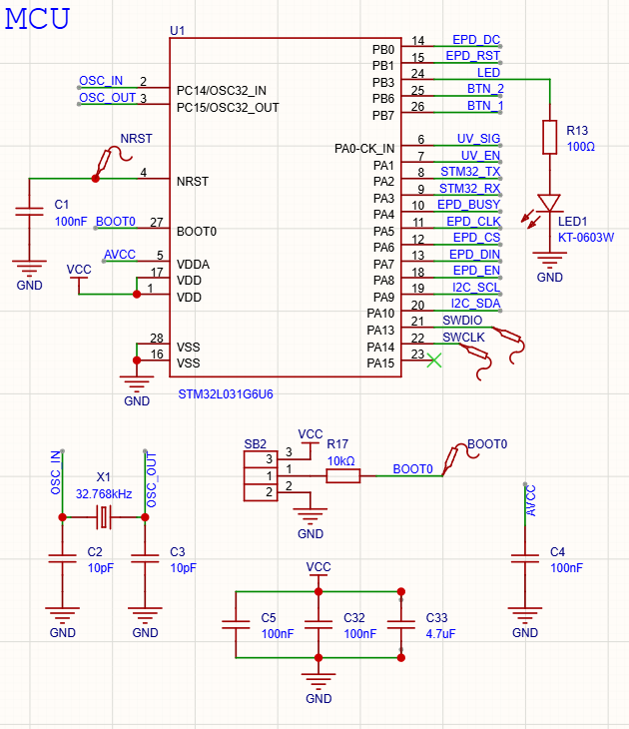

Datasheet Informations
- U1: STM32L031G6U6
Supply Voltage : 1.65V ~ 3.6V
Temperature : -40°C ~ 80°C
Package : UFQFPN-28
- X1: Seiko SC32S
Frequency : 32.768Hz
Load Capacitance : 6pF ~ 12pF

Capacitor & Resistor Requirements (AI Generated)
- C2 & C3
Capacitance : 6pF ~ 12pF
Voltage Rating : 10V or higher
Tolerance : +- 5% or lower
Minimum package : 0402
Type : C0F or NP0
Placement : near X1
- C1, C4, C5, C32
Capacitance : 100nF
Voltage Rating : 16V or higher
Tolerance : +- 10%
Minimum package : 0402
Type : X7R or X5R
Placement : Near designated pin
- C33
Capacitance : 4.7uF
Voltage Rating : 10V or higher
Tolerance : +- 10%
Minimum package : 0603
Type : X7R or X5R
Placement : Near power pin
- R13
Resistance : 100Ω
Tolerance : +- 5%
Power Rating : 1/16W
Minimum package : 0402
- R17
Resistance : 10kΩ
Tolerance : +- 5%
Power Rating : 1/16W
Minimum package : 0402

STM32 Pin Data
Source: Table 15. From STM32L031x4/6 Datasheet
Pin No. | Pin Name | Pin Type | Alternate/Additilonal Functions | Assigned As
1 | VDD | S | - | VCC
2 | PC14 - OSC32 IN | I/O | - | OSC_IN
3 | PC15 - OSC32 OUT | I/O | - | OSC_OUT
4 | NRST | I/O | - | NRST
5 | VDDA | S | - | AVCC
6 | PA0 - CK_IN | I/O | COMP1_INM6, ADC_IN0, RTC_TAMP2/WKUP1, LPTIM1_IN1, TIM2_CH1,  USART2_CTS, TIM2_ETR,  COMP1_OUT | UV_SIG (ANALOG INPUT: ADC_IN0)
7 | PA1 | I/O | EVENTOUT, LPTIM1_IN2,  TIM2_CH2, I2C1_SMBA,  USART2_RTS, TIM21_ETR,  COMP1_INP, ADC_IN1 | UV_EN (DIGITAL OUTPUT)
8 | PA2 | I/O | TIM21_CH1, TIM2_CH3,  USART2_TX, LPUART1_TX,  COMP2_OUT, COMP2_INM6,  ADC_IN2, RTC_TAMP3/RTC_TS/  RTC_OUT/WKUP3 | STM32_TX (LPUART1_TX)
9 | PA3 | I/O | TIM21_CH2, TIM2_CH4,  USART2_RX, LPUART1_RX,  COMP2_INP, ADC_IN3 | STM32_RX (LPUART1_RX)
10 | PA4 | I/O | SPI1_NSS, LPTIM1_IN1,  USART2_CK, TIM22_ETR  COMP1_INM4, COMP2_INM4,  ADC_IN4 | EPD_BUSY (DIGITAL INPUT)
11 | PA5 | I/O | SPI1_SCK, LPTIM1_IN2,  TIM2_ETR, TIM2_CH1,  COMP1_INM5, COMP2_INM5,  ADC_IN5 | EPD_CLK (SPI1_SCK)
12 | PA6 | I/O | SPI1_MISO, LPTIM1_ETR,  LPUART1_CTS, TIM22_CH1,  EVENTOUT, COMP1_OUT,  ADC_IN6 | EPD_CS (OUTPUT)
13 | PA7 | I/O | SPI1_MOSI, LPTIM1_OUT,  USART2_CTS, TIM22_CH2,  EVENTOUT, COMP2_OUT,  ADC_IN7 | EPD_DIN (SPI1_MOSI)
14 | PB0 | I/O | EVENTOUT, SPI1_MISO,  USART2_RTS, TIM2_CH3  ADC_IN8, VREF_OUT | EPD_DC (OUTPUT)
15 | PB1 | I/O | USART2_CK, SPI1_MOSI, LPUART1_RTS, TIM2_CH4,  ADC_IN9, VREF_OUT | EPD_RST (OUTPUT)
16 | VSS | S | - | GND
17 | VDD | S | - | VCC
18 | PA8 | I/O | MCO, LPTIM1_IN1, EVENTOUT,  USART2_CK, TIM2_CH1 | EPD_EN (OUTPUT)
19 | PA9 | I/O | MCO, I2C1_SCL, USART2_TX,  TIM22_CH1 | I2C_SCL
20 | PA10 | I/O | I2C1_SDA, USART2_RX, TIM22_CH2 | I2C_SDA
21 | PA13 | I/O | SWDIO, LPTIM1_ETR, LPUART1_RX | SWDIO
22 | PA14 | I/O | SWCLK, LPTIM1_OUT,  I2C1_SMBA, USART2_TX,  LPUART1_TX | SWCLK
23 | PA15 | I/O | SPI1_NSS, TIM2_ETR,  EVENTOUT, USART2_RX,  TIM2_CH1 | No Connection
24 | PB3 | I/O | SPI1_SCK, TIM2_CH2,  EVENTOUT, COMP2_INN | LED (DIGITAL OUTPUT)
25 | PB6 | I/O | USART2_TX, I2C1_SCL,  LPTIM1_ETR, TIM21_CH1  COMP2_INP | BTN_2 (DIGITAL INPUT)
26 | PB7 | I/O | USART2_RX, I2C1_SDA,  LPTIM1_IN2, COMP2_INP,  VREF_PVD_IN | BTN_1 (DIGITAL INPUT)
27 | BOOT0 | I | - | BOOT0
28 | VSS | S | - | GND

Note:
Pin Type:
- S: Supply Pin
- I: Input Only
- O: Output Only
- I/O: Input Output
- B: Boot0 Pin
- RST: Bidirectional reset pin

2. Power Circuitry
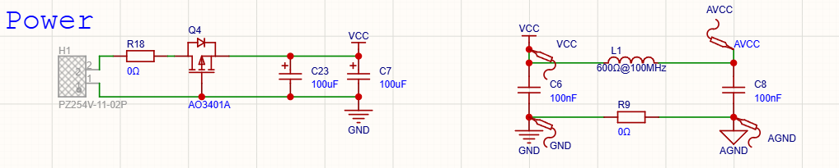

Electrical Rating Requirements
- Power Source : CR2032 Battery
  - Voltge : 3V
  - Internal R : 15Ω ~ 40Ω
  - Capacity : 200 mAh ~ 250 mAh
- Absolute Maximum
  - Voltage : 3.5V
  - Current : 3mA

Components Specification Requirements (AI Generated)
- L1 (Ferrite Bead)
Impedance : 600Ω @ 100 MHz
Current Rating : 200mA ~ 500mA
Minimum package : 0603
- C6, C8
Capacitance : 100nF
Voltage Rating : 16V or higher
Tolerance : +- 10%
Minimum package : 0402
Type : X7R or X5R
Placement : Near ferrite bead
- C23, C7
Capacitance : 100uF
Voltage Rating : 10V or higher
Tolerance : +- 20%
Minimum package : A-Case or similar
Type : Tantalum
Placement : Near ferrite bead
- R6, R18
Package : 0605

3. Push Button
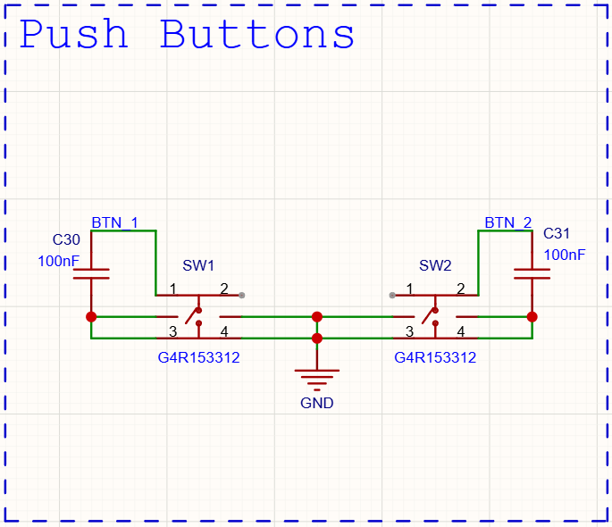

Components Specification Requirements (AI Generated)
- SW1, SW2
Minimum cap Ø : 2mm
Package : SMD
- C30, C31
Capacitance : 100nF
Voltage Rating : 16V or higher
Tolerance : +- 10%
Minimum package : 0402
Type : X7R or X5R
Placement : Near designated pin

4. SHT41
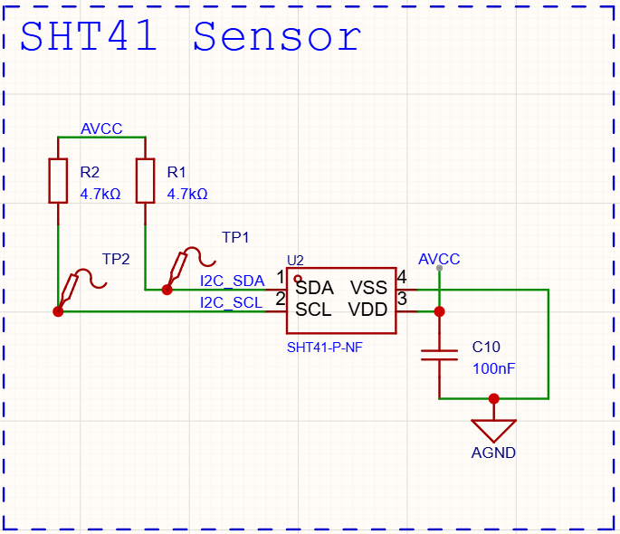

Datasheet Informations
- SHT41
Supply Voltage : 1.08V ~ 3.6V
Temperature : -40°C ~ 125°C
Current : 80 nA ~ 0.4 uA
Interface : I2C
I2C Address : 0x44/0x45/0x46

Components Specification Requirements (AI Generated)
- R1, R2
Resistance : 4.7kΩ
Tolerance : +- 5%
Power Rating : 1/16W
Minimum package : 0402
- C10
Capacitance : 100nF
Voltage Rating : 16V or higher
Tolerance : +- 10%
Minimum package : 0402
Type : X7R or X5R
Placement : Near the power pin

5. UV Sensor
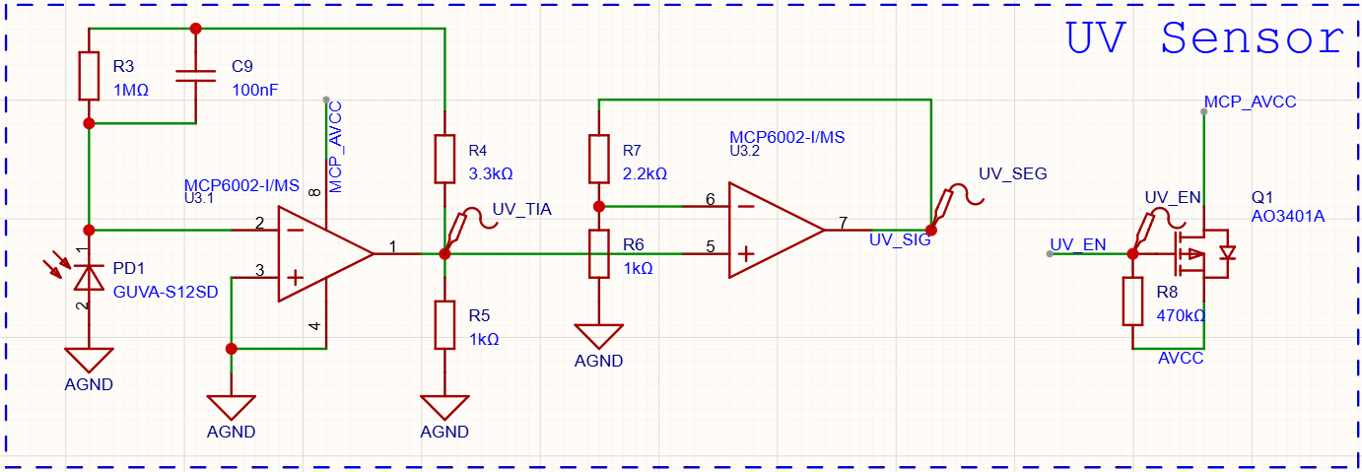
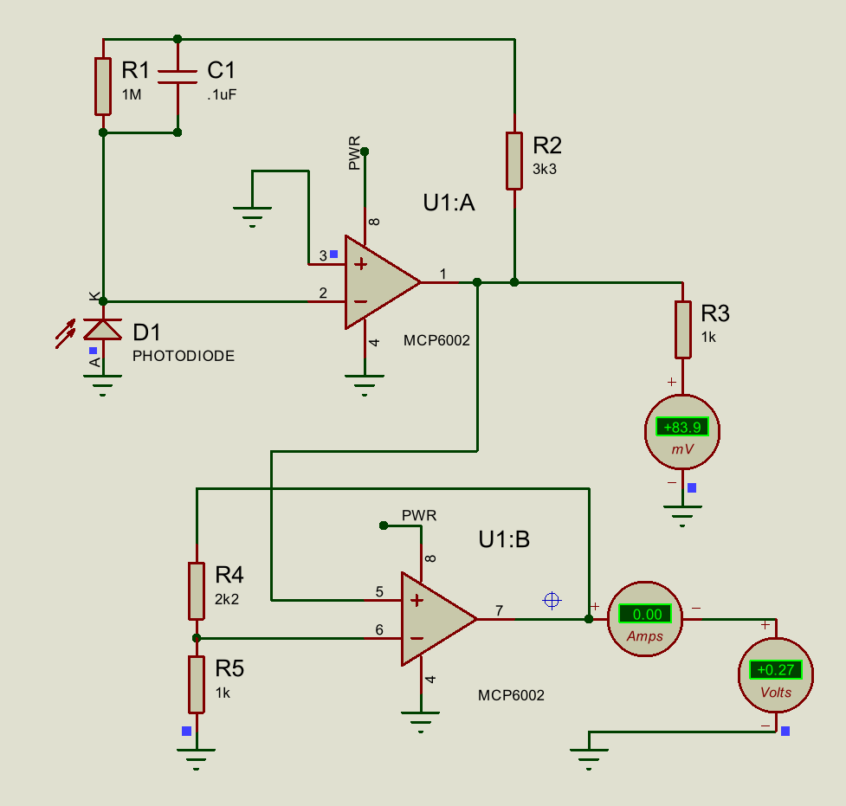
GUVA-S12SD Simulation Data

Datasheet Informations
- GUVA-S12SD
Spectral Range : 240 nm ~ 370 nm
Photo Current : 21 nA / 1 UVI
Soldering Temp : 260°C
- MCP6002
Supply Voltage : 1.8V ~ 6.0V
Operating Temp : -40°C ~ 85°C
Package : MSOP-8
Quiescent Current : 100 uA ~ 320 uA
Soldering Temp : 260°C
- AO3401A
MOSFET Type : P-Channel
Quiescent Current : 0.1uA ~ 1uA

Components Specification Requirements (AI Generated)
- C9
Capacitance : 100nF
Voltage Rating : 16V or higher
Tolerance : +- 10%
Minimum package : 0402
Type : X7R or X5R
Placement : Near photodiode
- R3
Resistance : 1M Ω
Tolerance : +- 1%
Power Rating : 1/16W
Minimum package : 0402
- R8
Resistance : 470k Ω
Tolerance : +- 5%
Power Rating : 1/16W
Minimum package : 0402
- Post-TIA Level Shifting
  - R4
Resistance : 3.3k Ω
Tolerance : +- 1%
Power Rating : 1/16W
Minimum package : 0402
- R5
Resistance : 1k Ω
Tolerance : +- 1%
Power Rating : 1/16W
Minimum package : 0402
- Op-Amp Gain
  - R6
Resistance : 1k Ω
Tolerance : +- 1%
Power Rating : 1/16W
Minimum package : 0402
- R7
Resistance : 2.2k Ω
Tolerance : +- 1%
Power Rating : 1/16W
Minimum package : 0402

Op-Amp Configuration Requirements:
Maximum output voltage : 1.2V (STM32 VREFINT)
TIA : 21 nA -> 21mV
Op-Amp Gain : 3.2x: 21mV -> 0.07V
GUVA-S12SD Simulation Data - Google Sheets

6. USB Interface
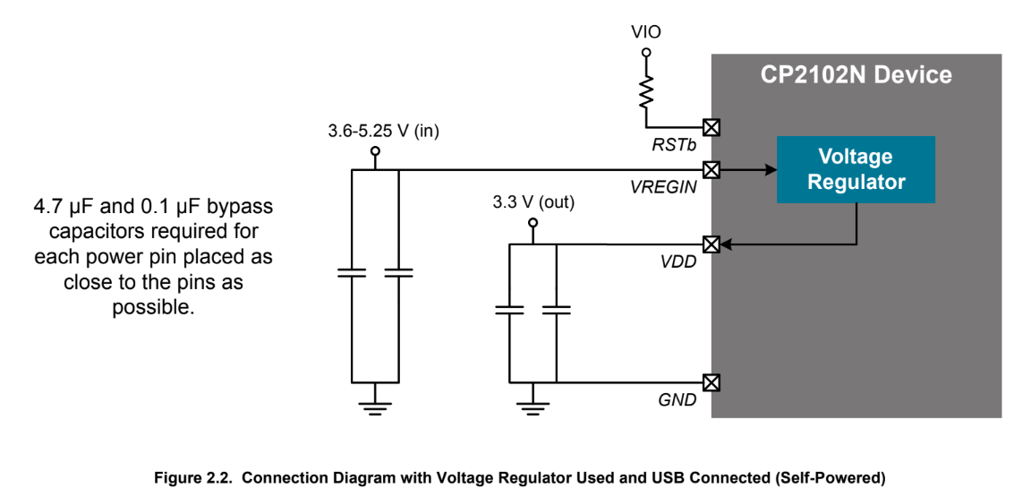
Typical Application (Source: CP2102N Datasheet)
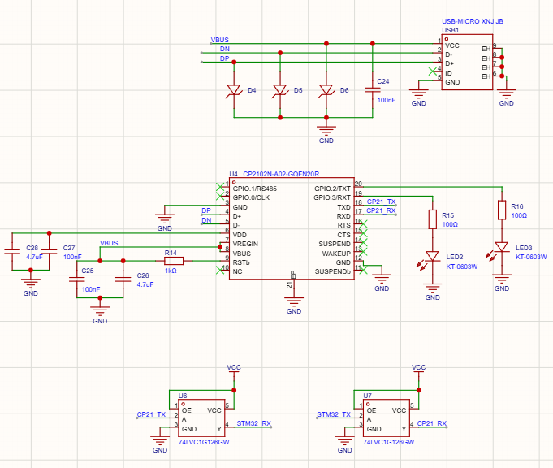

Datasheet Informations (CP2102N)
Part Number : CP2102N-A02-GQFN20R
Supply Volt (VREGIN): 3.6V to 5.25V (from USB VBUS)
Regulated VOUT : 3.3V (Internal Regulator Output)
Operating Temp : -40°C ~ 85°C
Comm. Interface : USB 2.0 Full-Speed (12 Mbps) to UART Bridge

Components Specification Requirements (AI Generated)
- USB1
Conn. Type : Micro-B USB Receptacle
Placement : Boardge edge
- C24, C25, C27
Capacitance : 100nF
Voltage Rating : 16V or higher
Tolerance : +- 10%
Minimum package : 0402
Type : X7R or X5R
Placement : Adjacent to VBUS and VDD
- C26, C28
Capacitance : 4.7uF
Voltage Rating : 16V or higher
Tolerance : +- 10%
Minimum package : 0603 or 0805
Type : X7R or X5R
Placement : In parallel with 100nF caps (C25, C27)
- R14
Resistance : 10k Ω
Tolerance : +- 5%
Power Rating : 1/16W
Minimum package : 0402
- R15, R16
Resistance : 100 Ω
Tolerance : +- 5%
Power Rating : 1/16W
Minimum package : 0402

Power Schema
- Powered by USB VBUS -> Internal 3.3v Regulator

Signal & Protection
- TVS ESD on D+ and D-
- TXD -> STM32_RX
RXD -> STM32_TX

7. EPD Boost Driver
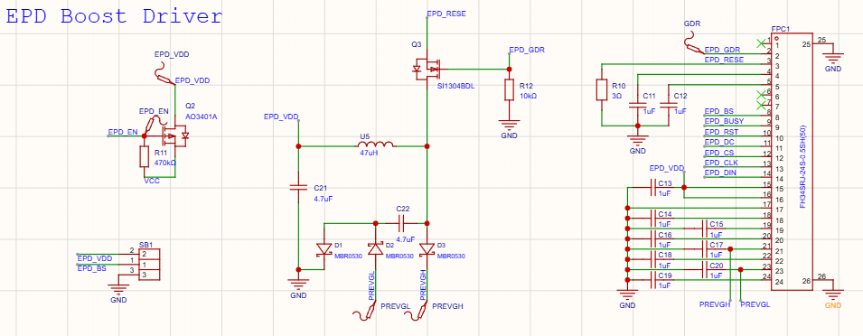
E-Paper Schematic Reference - Google Drive

Components Specification Requirements
- C21, C22
Capacitance : 4.7uF
Voltage Rating : 50V or higher
Tolerance : +- 10%
Minimum package : 0805
Type : X7R or X5R
- C11~C20
Capacitance : 1uF
Voltage Rating : 16V or higher
Tolerance : +- 10%
Minimum package : 0402
Type : X7R or X5R
Placement : Adjacent to corresponding FPC connector
- R10
Resistance : 3 Ω
Tolerance : +- 5%
Power Rating : 1/4W
Minimum package : 0603
- R11
Resistance : 470k Ω
Tolerance : +- 5%
Power Rating : 1/16W
Minimum package : 0402
- R12
Resistance : 10k Ω
Tolerance : +- 5%
Power Rating : 1/16W
Minimum package : 0402
- D1, D2, D3
Part Number : MBR0530
Reverse Voltage : 30V or higher
Forward Current : 0.5A
Package : SOD-123
- Q2 (AO3401A)
MOSFET Type : P-Channel
Quiescent Current : 0.1uA ~ 1uA
- Q3
Part Number : SI1304BDL
Voltage : 20v to 30v

Interface Mapping
  - FPC-24

Pin  No. | Datasheet  Name¹ | Reference  Name² | Reference Connection² | Current  Connection³
1 | NC | HLT_CTL | NC | NC
2 | GDR | GDR | Q3 Gate | Q3 Gate
3 | RESE | RESE | Q3 Source | Q3 Source
4 | NC | VGL | CAP | CAP
5 | VSH2 | VGH | CAP | CAP
6 | TSCL | TSCL | NC | NC
7 | TSDA | TSDA | NC | NC
8 | BS1 | BS | Solder Bridge | Solder Bridge
9 | BUSY | BUSY | GPIO | PA4 (10)
10 | RES# | RST | GPIO | PB1 (15)
11 | D/C# | D/C | GPIO | PB0 (14)
12 | CS# | CS | GPIO | PA6 (12)
13 | SCL | SCLK | GPIO (SPI) | PA5 (11)
14 | SDA | SDI | GPIO (SPI) | PA7 (13)
15 | VDDIO | VDDIO | 3V Power | EPD_VDD
16 | VC1 | VC1 | 3V Power | EPD_VDD
17 | VSS | VSS | GND | GND
18 | VDD | VDD | CAP | CAP
19 | VPP | VPP | CAP | CAP
20 | VSH | VSH | CAP | CAP
21 | VGH | PREVGH | Diode | D3
22 | VSL | VSL | CAP | CAP
23 | VGL | PREVGL | Diode | D2
24 | VCOM | VCOM | CAP | CAP

¹ from waveshare 2.13 e-Paper V4 Specification
² from reference design
³ on this implementation (v1.2)

